Multi-AI Chatbot System Performance Metrics and Testing Results

Performance Metrics of RAG Model:

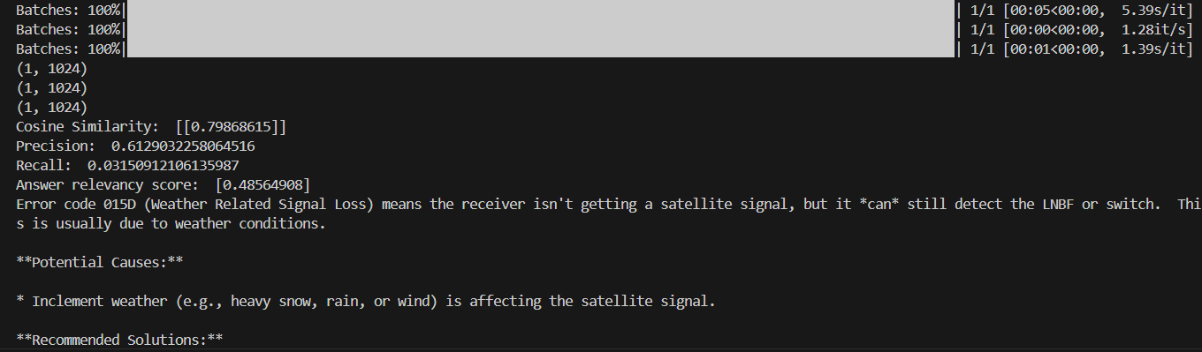

Testing Results:

Technical Query:

1. How should a technician prioritize troubleshooting multiple error codes (e.g..015, 021, 311)?

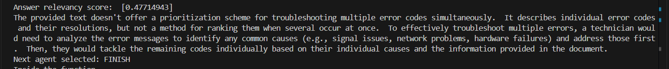

1. How can intermittent signal loss on a Hopper 3 be diagnosed and resolved?

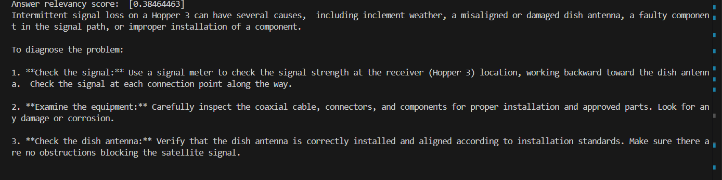

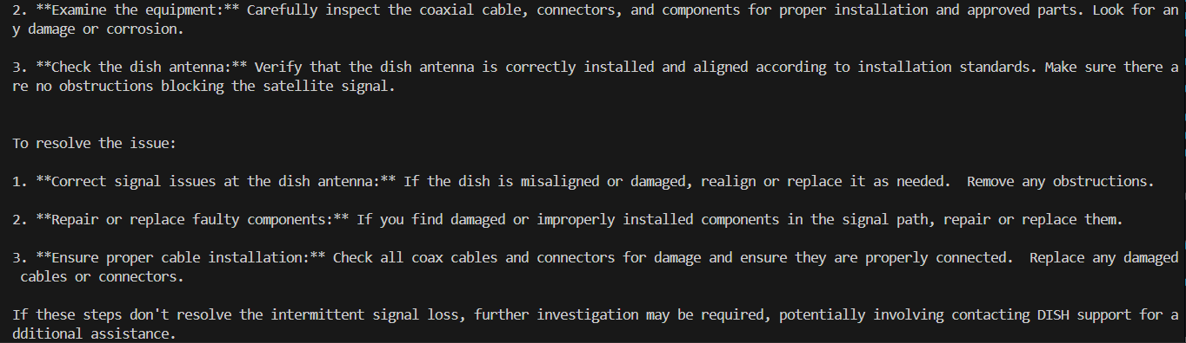

Marketing Agent Queries:

1. How much was spent on Meta (Facebook/Instagram) ads for local campaigns in [Jun, 2023]?

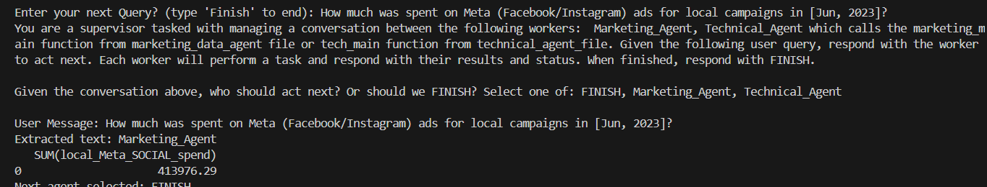

1. How did the stock market index correlate with sales in the first half of [2024l?



1. What’s the weather today?

